



A
Project Report on
PERSONAL FINANCE TRACKER DASHBOARD
Submitted in partial fulfillment of completion of the course
AI Micro Degree
Year 2026

Submitted by:
Ashi
Kashish Gautam
Bhoomi
Khushi Kashyap

Under Guidance of:
Deepika Singh (Edunet)

Abstract
The Personal Finance Analysis Dashboard is an easy-to-use tool that tracks income, expenses, savings, and transactions. It shows clear insights through KPIs and simple charts to help users understand their spending habits. The dashboard helps in monitoring money, controlling expenses, and making better budgeting decisions. Overall, it makes financial management simple and more organized using Power BI.

Acknowledgement
The Personal Finance Analysis Dashboard helps track income, expenses, and savings in a simple way. It uses clear charts and KPIs to show spending patterns. This dashboard helps users manage money better and make smart budgeting decisions using Power BI.

Team Composition and Workload Division:

Ashi: Dashboard creation & presentation, video making
Bhoomi: Dashboard support & data handling, video making
Kashish Gautam: Presentation & documentation
Khushi Kashyap:

Table of Contents

Abstract ------------------------------------------------------------ i
Acknowledgement -------------------------------------------------- ii
Team Composition and Workload Division ------------------- iii
- Introduction to Problem -------------------------------------- 1
- Literature Review ----------------------------------------------- 2
- Proposed Solution ---------------------------------------------- 3
- Requirements ---------------------------------------------------- 4
4.1 Technology Stack ------------------------------------------ 4
4.2 Hardware -------------------------------------------------- 5
4.3 Software --------------------------------------------------- 5
4.4 Deployment Environment ----------------------------- 6
- User Requirements -------------------------------------------- 7
- Design Documentation ----------------------------------------- 8
6.1 Data Design ---------------------------------------------- 8
6.2 Interface Design --------------------------------------- 9
6.3 Database Structure ----------------------------------- 10
- Implementation Details --------------------------------------- 11
- Testing ----------------------------------------------------------- 13
- Deployment ------------------------------------------------------- 14
- Future Scope --------------------------------------------------- 15
- Conclusion ------------------------------------------------------ 16
Appendix A – Project Code -------------------------------------- 17
Appendix B – Screenshot of Project ---------------------------- 20
Appendix C – Abbreviation & References -------------------- 22

- Introduction to Problem
In today’s digital era, managing personal finances has become increasingly complex due to multiple income sources and daily transactions across various platforms. Many individuals face difficulties in tracking their expenses, monitoring savings, and understanding their spending patterns effectively.
Without proper analysis and visualization, financial decisions are often made without clear insights, leading to overspending and poor budgeting. Therefore, there is a need for a structured and interactive dashboard that provides clear financial insights and supports better decision-making.

- Literature Review
Previous studies emphasize the significance of structured financial analysis and data visualization in effective personal finance management. Traditional tracking methods, such as manual records and spreadsheets, provide limited analytical capabilities. In contrast, modern Business Intelligence tools enable comprehensive data analysis through interactive dashboards and key performance indicators. These approaches support informed decision-making and form the conceptual foundation of this project.

3.Proposed Solution
To effectively address the identified challenges in personal financial management, we propose the design and implementation of a comprehensive Personal Finance Analysis Dashboard. The solution leverages Business Intelligence tools to transform raw transactional data into structured, interactive, and insightful visual reports.
The dashboard integrates data modelling, key performance indicators (KPIs), and analytical visualizations to provide a clear overview of income, expenses, savings, and spending patterns. This data-driven approach enhances financial transparency, supports informed decision-making, and promotes effective budgeting and long-term financial planning.

4. Requirements
4.1 Technology Stack
The project is developed using modern Business Intelligence and data analytics technologies. The primary tool used for dashboard development is Microsoft Power BI, which enables data modelling, visualization, and report generation. Data transformation and cleaning are performed using Power Query, and DAX (Data Analysis Expressions) is utilized for creating calculated measures and KPIs. The dataset is maintained in CSV/Excel format for structured data handling.

  - Hardware
Technology Stack
- Microsoft Power BI – Dashboard development, data visualization, and reporting
- Power Query – Data cleaning and transformation
- DAX (Data Analysis Expressions) – Calculated measures and KPIs
- CSV / Excel – Dataset storage and structured data handling
Hardware
- Computer / Laptop
- Minimum 4 GB RAM (8 GB recommended)
- Intel i3 or equivalent processor or higher
- Minimum 10 GB free disk space
- Display resolution 1366 × 768 or higher
Software
- Windows Operating System
- Microsoft Power BI Desktop
- Microsoft Excel (for dataset handling, optional)
Deployment Environment
- The dashboard is developed and deployed in a local environment using Power BI Desktop.
- Financial data is imported from CSV/Excel files.
- The system performs data modeling and analysis to generate KPIs such as income, expenses, savings, and transaction trends.
- Results are displayed through interactive charts, cards, and slicers for better financial insights and decision-making.

  - Software
The following software components are required:
- Windows 10/11 Operating System
- Microsoft Power BI Desktop
- Microsoft Excel (for dataset preparation)
  - Deployment Environment
The dashboard can be deployed locally using Power BI Desktop for analysis and reporting. For broader accessibility and collaboration, the solution can be published to Power BI Service (Cloud Environment), enabling secure online access, sharing, and real-time updates.

- User Requirements

• The system shall provide clear visualization of total income, expenses, and savings through interactive KPIs and charts.
• The dashboard shall enable users to analyze financial data by category, time period, and account type using filters and slicers.
• The system shall ensure accuracy, consistency, and reliable calculation of financial metrics.
• The interface shall be user-friendly, responsive, and capable of handling future data expansion efficiently.
The system shall support real-time data updates and dynamic report generation.
The dashboard shall allow secure sharing and accessibility through a suitable deployment platform.

6. Design Documentation

6.1 Data Design
The data design focuses on organizing and structuring financial transaction data in a clean and consistent format. The dataset includes attributes such as transaction date, category, income, expenses, and account type. Data cleaning and transformation are performed to remove inconsistencies, handle missing values, and standardize formats. Calculated measures and KPIs are created to generate meaningful insights such as total income, total expenses, and net savings.

6.2 Interface Design
The interface is designed to be simple, interactive, and user-friendly. The dashboard layout includes KPI cards for summary metrics, bar and column charts for category-wise comparison, line charts for trend analysis, and slicers for dynamic filtering. Proper alignment, color consistency, and visual hierarchy are maintained to ensure clarity and ease of navigation.

6.3 Database Structure
The database structure follows a structured tabular format, where financial data is stored in rows and columns. Relationships between relevant fields such as date and category are defined to support accurate analysis. The model is designed to ensure scalability, data integrity, and efficient performance during report generation.

7. Implementation Details
The implementation of the Personal Finance Analysis Dashboard was carried out in a structured and systematic manner. Initially, the dataset was imported into the business intelligence tool and examined for data quality issues. Data cleaning and transformation were performed using Power Query to handle missing values, remove inconsistencies, and standardize formats.
After preparing the dataset, a data model was created by defining relationships between relevant fields such as date, category, and transaction type. Calculated columns and measures were developed using DAX to compute key metrics including total income, total expenses, and net savings.
Finally, interactive visualizations such as KPI cards, bar charts, column charts, and line charts were designed and arranged in a user-friendly layout. Slicers and filters were added to enable dynamic analysis, ensuring that the dashboard delivers accurate, responsive, and insightful financial reports.

8. Testing
The dashboard was tested to ensure accuracy, performance, and usability. Data validation testing was conducted to verify that all financial calculations, including total income, total expenses, and savings, were correctly computed. Cross-verification with the original dataset was performed to maintain data consistency and reliability.
Functional testing ensured that all filters, slicers, and interactive visuals responded accurately to user selections. Performance testing was also carried out to confirm smooth report loading and responsiveness. Overall, the testing process ensured that the dashboard operates efficiently and delivers reliable financial insights.

9. Deployment
The completed dashboard was deployed using Microsoft Power BI to ensure accessibility and usability. Initially, the solution was developed and tested in Power BI Desktop. After successful validation, the dashboard was published to the Power BI Service (cloud platform) for secure online access and sharing.
The deployment environment allows authorized users to view reports, interact with visuals, and access real-time updates from any location. Proper access controls and permissions are implemented to ensure data security and confidentiality. The deployment strategy ensures scalability, reliability, and ease of maintenance for future enhancements.

10. Future Scope
The dashboard can be further enhanced by integrating real-time bank APIs for automated data updates. Advanced analytics such as predictive forecasting and budget recommendations can be incorporated. Additional features like mobile optimization and multi-user access control can also improve usability and scalability.
11. Conclusion
The Personal Finance Analysis Dashboard provides a structured and data-driven approach to managing financial information. By transforming raw transaction data into interactive visual insights, the system supports effective budgeting, expense monitoring, and informed decision-making. The project successfully demonstrates the practical application of Business Intelligence tools in personal finance management.

Appendix A Project Code
This section includes DAX formulas, calculated measures, and data transformation steps used in the dashboard development. It contains key calculations such as:
- Total Income Measure
Total Income =
CALCULATE (
SUM('FinanceData'[Amount]),
'FinanceData'[Transaction Type] = "Credit"
)

- Total Expense Measure
Total Expense =
CALCULATE (
SUM('FinanceData'[Amount]),
'FinanceData'[Transaction Type] = "Debit"
)
- Net Savings Calculation
Savings =
[Total Income] - [Total Expense]
- Data Cleaning Steps (Power Query)
let
Source = Excel.Workbook(File.Contents("C:\YourFilePath\FinanceData.xlsx"), null, true),
Sheet = Source{[Item="Sheet1”, Kind="Sheet"]}[Data],
PromotedHeaders = Table.PromoteHeaders(Sheet, [PromoteAllScalars=true]),
changed Type = Table.TransformColumnTypes(PromotedHeaders,{
{"Transaction ID", type text},
{"Date", type date},
{"Category", type text},
{"Transaction Type", type text},
{"Account Name", type text},
{"Amount", type number}
}),
RemovedBlankRows = Table.SelectRows(Changed Type, each [Amount] <> null),
RemovedDuplicates = Table. Distinct (RemovedBlankRows, {"Transaction ID"})
in
RemovedDuplicates
- Total Transactions
Total Transactions =
COUNT ('FinanceData'[Transaction ID])
- Income vs Expense (Year Wise)
Total Amount = SUM('FinanceData'[Amount])
- Spending by Category
Category Wise Amount =
SUM('FinanceData'[Amount])
- Spending by Account
Account Wise Spending =
SUM('FinanceData'[Amount])
- Monthly Income Vs Expense
Monthly Amount = SUM('FinanceData'[Amount])

Appendix B Screenshot of Project

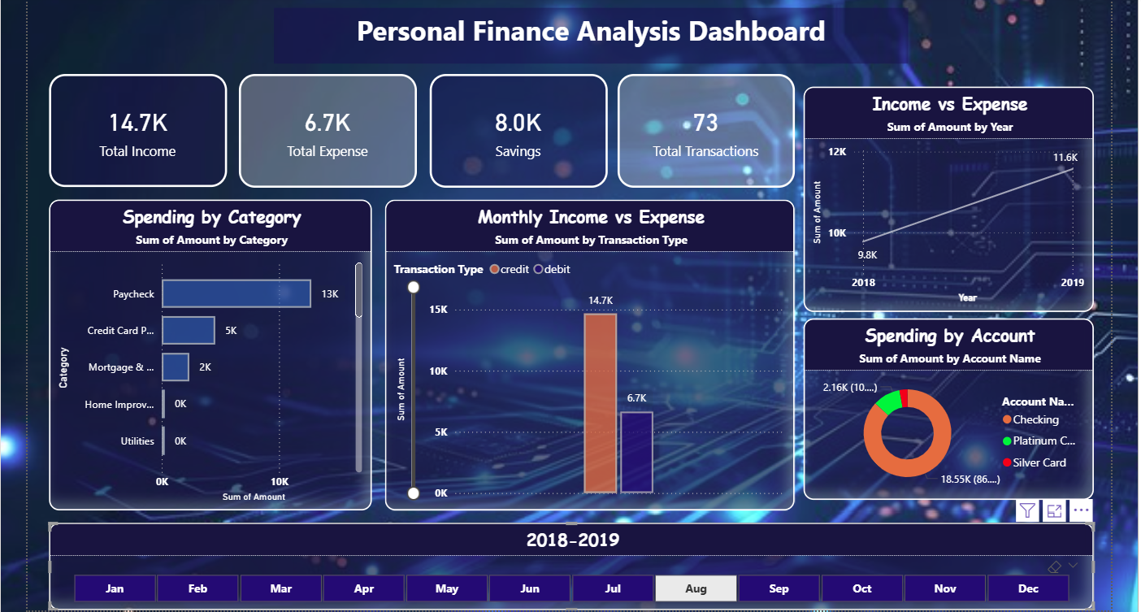

Appendix C – Abbreviation & References

Abbreviations
BI – Business Intelligence
KPI – Key Performance Indicator
DAX – Data Analysis Expressions
CSV – Comma Separated Values

References
- Microsoft Power BI Documentation
- Data Visualization and Business Intelligence Research Articles
- Online Learning Resources and Technical Guides
- Academic textbooks on Business Intelligence and Data Analytics
- Industry reports on Financial Data Analysis and Dashboard Design
- Technical blogs and case studies related to data modelling and KPI development

